

Western Australian Certificate of Education
ATAR course examination, 2020

Question/Answer Booklet

12 PHYSICS
Name

Practical Test - Circular Motion

Student Number: In figures

Mark: $\frac{}{\text{25}}$
In words

Time allowed for this paper
Reading time before commencing work: five minutes
Working time for paper: fifty minutes

Materials required/recommended for this paper

To be provided by the supervisor
This Question/Answer Booklet
Formulae and Data Booklet

To be provided by the candidate
Standard items: pens, (blue/black preferred), pencils (including coloured), sharpener, correction fluid/tape, eraser, ruler, highlighters
Special items: non-programmable calculators satisfying the conditions set by the School Curriculum and Standards Authority for this course

Important note to candidates
No other items may be taken into the examination room. It is your responsibility to ensure that you do not have any unauthorised notes or other items of a non-personal nature in the examination room. If you have any unauthorised material with you, hand it to the supervisor before reading any further.
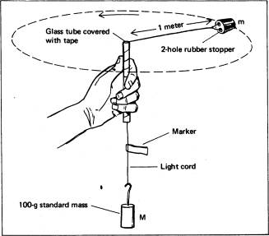
Experimental outline

When the plastic tube is moved in a small circle above your head, the rubber cork moves around in a horizontal circle at the end of a string that passes through the tube and has a mass hanger with slotted masses suspended from its lower end.

Mass of slotted weights (M) used = 0.100 kg

The following results were obtained.

Radius r (m) | Time for 20 swings (s) |  | Average period T  ( ) | V =$\frac{2πr}{T}$  (ms⁻¹) | V²  ( )
 | Trial 1 | Trial 2
0.30 ± 0.02 | 15.1 ± 0.5 | 15.2 ± 0.5 | 0.76 ± 0.05
0.40 ± 0.02 | 16.9 ± 0.5 | 17.0 ± 0.5 | 0.85 ± 0.05
0.50 ± 0.02 | 18.5 ± 0.5 | 18.9 ± 0.5 | 0.94 ± 0.05
0.60 ± 0.02 | 21.4 ± 0.5 | 21.20 ± 0.5 | 1.07 ± 0.05
0.70 ± 0.02 | 22.9 ± 0.5 | 22.8 ± 0.5 | 1.14 ± 0.05

1. Complete the table, remembering to complete unfinished units that should appear and expressing data to an appropriate number of significant figures.

(Do not include the absolute uncertainties - that will be tested later.) (5 marks)

2. Graph the speed squared (v²) versus the radius (r) on the grid provided.
(Plot v² on the y-axis and radius, r on the x-axis) (4 marks)

3. Determine the gradient of the graph. Be sure to indicate on the graph which points were used. (4 marks)

4. Use the gradient to determine the mass of the rubber stopper. Show all working. (4 marks)

5. Consider the measurement: r = 0.60 ± 0.02. Calculate the percentage error in the measurement and therefore the absolute error in the measurement for the velocity (v) column. (4 marks)

6. Describe two errors affecting the results of the experiment above. (2 marks)

7. Give two reasons why it is desirable to use 20 swings to calculate a value for the
period (T). Consider aspects of error and measuring difficulties. (2 marks)

